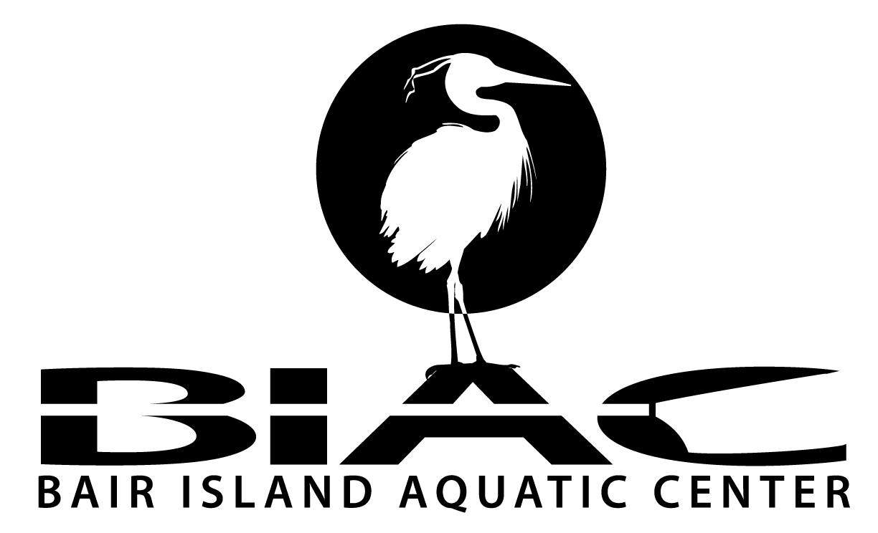

Bair Island Aquatic Center
1450 Maple Street
Redwood City, CA 94063
650.474.2247
www.gobair.org

FOR OFFICE USE ONLY Date Received: _____________

Current Member? _______ Amount Paid: _________ CK# ___________

Rate: _________ By: ___________ Space Assigned: _________________

Private Boat Storage Agreement

INSTRUCTIONS:
Applications and payment for boat (“Boat”) storage are due at BIAC December 1 of each year. Storage fees are annual and refunds are at the sole discretion of BIAC. Space is assigned to current BIAC members as available with payment of one year’s fees and completed application. A separate application is required for each storage space requested. For complete information on Boat storage policies, see the BIAC Rules and Regulations.

Name: Boat Type:
Address: Maker:
Boat Name:
Phone (h): Length Overall:
Phone (w): Other Equipment:
E-Mail:
I hereby apply for space in which to store my Boat at Bair Island Aquatic Center and I hereby acknowledge and agree to the following terms:
- Rules and Regulations. I agree to comply at all times with the BIAC Rules and Regulations regarding private equipment storage, as those Rules and Regulations may be revised by BIAC from time to time.
- Secured Boat. I agree to keep my Boat(s) properly secured to the rack it is stored in at all times when not in use.
- Identification. I agree that my Boat(s) will be at all times identified with indelible ink and/or label conspicuously placed showing my name and contact information.
- Access to Boat. I understand that my Boat may be moved for certain events, and I hereby authorize BIAC to move it for me. I acknowledge that it is my responsibility to provide BIAC with the correct combination or key location for all Boat stored at BIAC, and that failure to do so may result in lock being cut in order to move Boat.
- No Transfer. I understand that I may not assign or otherwise transfer to any other person the storage space assigned to me by BIAC. I agree to notify BIAC if I transfer ownership of my Boat or if any of the information on this application changes. I understand that acceptance of this application does not guarantee a storage space.
- No Bailment. I agree that any granting of storage space shall constitute a rental of space only. No bailment of any kind is intended or created either expressed or implied. I further agree that all risk or loss, damage or destruction of said Boat or other property of mine shall at all times be borne by me.
- Removal of Boat. I authorize BIAC to remove my Boat from BIAC property at my risk and expense, including storage costs and an administrative fee, should I fail to have a valid storage agreement in force, should I fail to pay my storage fee in full when due, or should my membership lapse or be terminated for any reason. In addition, BIAC may, at its discretion, assume ownership of a boat that has been deemed abandoned.
- Work on Boat: I will be solely liable for damage to other equipment, to BIAC property, and the environment that may occur in connection with work being done on my Boat. BIAC reserves the right to prevent or stop any work being performed by me or outside contractor that is hazardous to the environment or disruptive to BIAC operations.
- Responsibility: Storage space is granted by BIAC with the distinct understanding, and I hereby agree, that neither BIAC nor any of its directors, officers, members, employees, or agents assume any responsibility whatsoever for the safety of any Boat I may store at the BIAC site, either ashore or moored at the site or adjoining waters or during launching, rowing or paddling operations, and none of them shall be liable to me or any person claiming by, through, or under me for fire, theft, or any damage whatsoever to any such Boat, or any property or the person of mine, my family, employees, guests, or invitees, however caused. I hereby release BIAC, its agents, directors, officers, members and employees from any an all claims related to the storage of Boat under this agreement. In addition, I agree to indemnify and hold harmless BIAC and its agents, directors, officers, members and employees against any and all liability, loss, damages, claims, suits, judgments, costs and expenses, including attorneys fees, resulting from and arising out of property damage and/or personal injuries caused by me, my family, employees, agents, guests or invitees.
- Miscellaneous. No terms or conditions herein may be changed or modified unless in writing, signed by both BIAC and me. This Agreement will be governed by California law.

I HAVE READ THE FOREGOING AND ACCEPT ALL TERMS AND CONDITIONS.

_______________________________ _______________
Signature Date

Printed Name

Amt Enclosed: $

