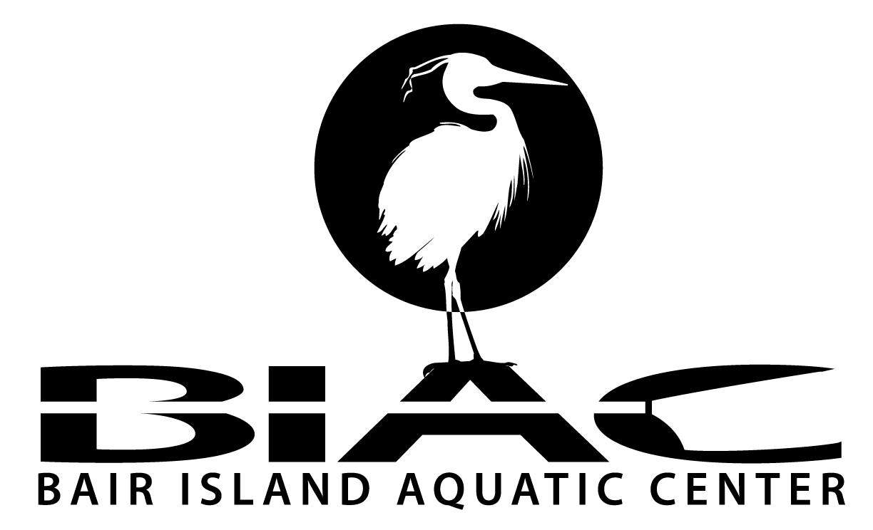

Office use only
Credit card Y or N
Check # _______________
Amount________________
Date___________________
Entered by______________
Programs_______________

_______________ ______________
1450 MAPLE ST. REDWOOD CITY, CA. 94063 (650-474-2447)

MEMBERSHIP FORM – Intake / Update (please circle one)

NAME_______________________________________________________________________________________________

ADDRESS____________________________________________________________________________________________

CITY, STATE, ZIP____________________________________________________________________________________

PHONE: [Required] _______________________________________

EMAIL [Required]_____________________________________________________________ DoB__________________

Row, Scull, Paddle, or Other__________________________________ Novice or Experienced?_____________________

- Are you currently certified in First Aid?_________________________ CPR?________________________
- Can you swim a continuous distance of at least 100 meters? ______________________________________
- Do you have any health issues that might limit your physical activity?______________________________
If yes, please explain____________________________________________________________________________
- How did you find out about the Center (BIAC)?_______________________________________________________

MEMBERSHIP DUES

Most adult paddling memberships are $250/yr and most rowing memberships are $400/yr, as detailed below.
Program coaching fees are separate and unique to each program – contact your program leader for specifics.

Annual Membership:  Circle either  - BIAC Master with 12 hours/yr volunteer work: $200 /yr  - BIAC Master waiving volunteer commitment: $450 /yr  - BIAC Junior (no volunteer requirement) $200 /yr  In Addition, please circle all that apply  - BIAC Rowing Equipment Annual usage: $200 / year  - BIAC Paddling Equipment Annual Usage: $50 / year  - Private Rowing Shell Storage at BIAC: $200 / year  - Private Paddling Shell Storage at BIAC: $150 / year | Summer Membership  Circle either  - Adult: $150 / Four months  - Student: $125 / Four months  - High School: $125 / Four months  Note: Members under 18 must get coach consent to join and are not allowed on the water without supervision.

Membership Notes:
- Members storing their own equipment at BIAC need to sign the Private Boat Storage Agreement (form at www.gobair.org/membership).
- Full time students may receive a 25% discount. Please contact the board@gobair.org with the details of your student status.
- Unemployed members may be eligible for a one time annual fee waiver in exchange for a 25 hour volunteer commitment. Please contact the board@gobair.org for more information. Other financial hardships may be considered on a case-by-case basis.

BIAC BASIC FIVE COMMANDMENTS

1. Everyone must be approved by a coach prior to using club equipment.

2. Know the waterway and BIAC safety and care procedures (www.gobair.org/safety_and_care).

3. Sign in, Sign out, and report incidents using the Log Shed

4. Sign up to the BIAC_AC Yahoo Group for club communications.

5. Advise the BIAC Board (board@gobair.org) of any changes in your contact information.

The full text of BIAC Rules and Regulations is at www.gobair.org/membership

I acknowledge that I have read, understand, and will abide by BIAC’s rules and regulations (which may be amended by the BIAC Board with or without notice).

Volunteer Requirement: Initial near your selection:
[ ] I am committing to 12 hours / year
[ ] Waiver bought ($250)
[ ] Temp Summer membership, does not Apply

Total Membership Fee: $_________

MEMBER SIGNATURE_____________________________DATE________________

Parent or Guardian (if member is <18):

SIGNATURE_____________________________DATE________________

