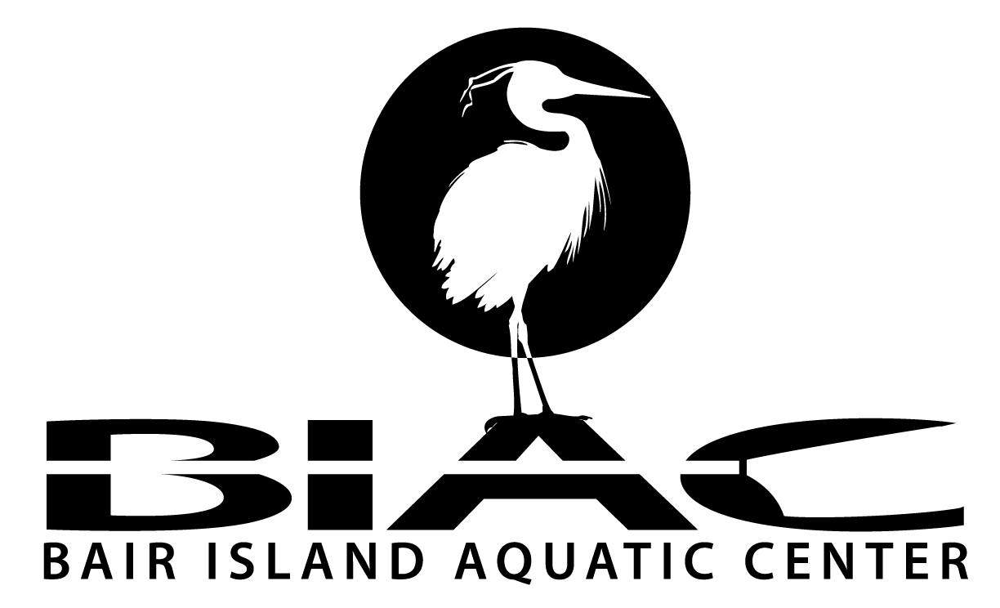

Office use only
Credit card Y or N
Check # _______________
Amount________________
Date___________________
Entered by______________
Programs_______________

_______________ ______________
1450 MAPLE ST. REDWOOD CITY, CA. 94063 (650-474-2447)
ATTN: MEMBERSHIP COORDINATOR

MEMBERSHIP FORM – NEW / UPDATE (please circle one)

ANNUAL MEMBERSHIP DUES;
REGULAR: $400 PAID ANNUALLY Rower (Sweep and Scull) $250.00 plus $150.00 equipment fee
$250 PAID ANNUALLY Sculler with storage contract
$250 PAID ANNUALLY Paddler
STUDENT: $250 PAID ANNUALLY
TEMP MEMBER: $100 3 months only (Novice paddler, Sculling or Sweep lessons)
INTRO CLASSES: Cost varies per class – see www.gobair.org programs and contact pages

NAME_______________________________________________________________________________________________

ADDRESS____________________________________________________________________________________________

CITY, STATE, ZIP____________________________________________________________________________________

PHONE (H)__________________________________________PHONE (W)______________________________________

EMAIL__________________________________________________________________________DOB_________________

ROW, SCULL, PADDLE OR OTHER_____________________________NOVICE OR EXPERIENCED?____________

DO WISH TO STORE A BOAT, OARS, PADDLES OR OTHER EQUIPMENT AT BIAC?_______________________

IF SO, PLEASE LIST__________________________________________________________________________________

ARE YOU CURRENTLY CERTIFIED IN FIRST AID?_________________________CPR?_______________________

CAN YOU SWIM A CONTINUOUS DISTANCE OF AT LEAST 100 METERS?________________________________

DO YOU HAVE ANY HEALTH PROBLEMS THAT MIGHT LIMIT YOUR PHYSICAL ACTIVITY?_____________

IF YES, PLEASE EXPLAIN_____________________________________________________________________________

HOW DID YOU FIND OUT ABOUT THE CENTER?_______________________________________________________

I acknowledge that I have read and understand the current BIAC rules and regulations. I agree to abide by all BIAC rules and regulations (which may be amended by BIAC with or without notice)

MEMBER SIGNATURE__________________________________________DATE________________
Reminders: BIAC Website = www.gobair.org Read about Safety and Care. Communications: Sign up on Yahoo Groups to BIAC_AC

AQUATIC ACTIVITY RELEASE AND WAIVER OF LIABILITY, ASSUMPTION OF
RISK, AND INDEMNITY AGREEMENT (“AGREEMENT”)

IN CONSIDERATION of being given the opportunity to participate in any way in any BA1R ISLAND AQUATIC CENTER (’Club”) activities (“Activity”) I, for myself, my personal representatives, assigns, heirs, and next of kin:

1. ACKNOWLEDGE, agree, and represent that I understand the nature of Rowing and Paddling Activities, both on water and land based, and that I am qualified, in goad health, and in proper physical condition to participate in such Activity;

2. FULLY UNDERSTAND that: (a) ROWING AND PADDLING ACTIVITIES INVOLVE RISKS AND DANGERS of serious bodily injury, including permanent disability, paralysis, and death (“Risks”); (b) These Risks and dangers may be caused by my own actions, or inactions, the actions or inactions of others participating in the Activity, the condition in which the Activity takes place, or the negligence of the Releasees named below; and (c) there may be other risks and social and economic losses either not known to me or not readily foreseeable at this time; and I FULLY ACCEPT AND ASSUME ALL SUCH RISKS AND ALL RESPONSIBILITY FOR LOSSES, COSTS, AND DAMAGES I incur as a result of my participation in the Activity;

3. AGREE AND WARRANT that I will examine and inspect each Activity in which I take part as a member of the Club and that, if I observe any condition which I consider to be unacceptably hazardous or dangerous, I will notify the proper authority in charge of the Activity and will refuse to take part in the Activity until the condition has been corrected to my satisfaction;

4. HEREBY RELEASE, discharge, and covenant not to sue USRowing, the Club, their administrators, directors, agents, officers, members, volunteers, and employees, other participants, regatta organizers, any sponsors, advertisers, and, if applicable, owners and lessors of premises on which the Activity takes place, (each considered one of the Releasees herein) from all liability, claims, demands, losses, or damages on my account caused or alleged to be caused in whole or in part by the negligence of the Releasees or otherwise, including negligent rescue operations; and I further agree that if, despite this release and waiver of liability, assumption of risk, and indemnity agreement, I, or anyone on my behalf, makes a claim against any of the Releasees, I WILL INDEMNIFY, SAVE, AND HOLD HARMLESS each of the Releasees from any litigation expenses, attorney fees, loss, liability, damage, or cost which any may incur as the result of such claim.

I have read this Agreement, Fully understand its terms, understand that I have given up substantial rights by signing it and have signed it freely and without any inducement or assurance of any nature and intend it to be a complete and unconditional release of all liability to the greatest extent allowed by law and agree that if any portion of this agreement is held to be invalid the balance, notwithstanding, shall continue in full force and affect.

PRINTED NAME OF PARTICIPANT_________________________________________________________________

ADDRESS ________________________________________________________________________________________

PHONE ______________________________________________DATE________________________________________

PARTICIPANTS SIGNATURE (age 18 or over) _____________________________________________________________

PARENTAL CONSENT

AND I, the minor’s parent and/or legal guardian, understand the nature of rowing activities and the minor’s experience and capabilities and believe the minor to be qualified to participate in such activity. I hereby release, discharge, covenant not to sue, and AGREE TO INDEMNIFY AND SAVE AND HOLD HARMLESS each of the Releasees from all liability, claims, demands, losses, or damages on the minor’s account caused or alleged to be caused in whole or in part by the negligence of the releases as or otherwise. including negligent rescue operations, and further agree that If, despite this release, I, the minor, or anyone on the minor’s behalf makes a claim against any of the above releasees, I WILL INDEMNIFY, SAVE, AND HOLD HARMLESS each of the Releasees from any litigation expenses, attorney fees, loss liability, damage, or cost any may incur as the result of any such claim.

PRINTED NAME OF PARENT/GUARDIAN__________________________________________________________________________________

ADDRESS____________________________________________________________________________________________

PHONE DATE______________________________________

PARENT/GUARDIAN SIGNATURE ______________________________________________________
(only if participant is under the age of 18)

