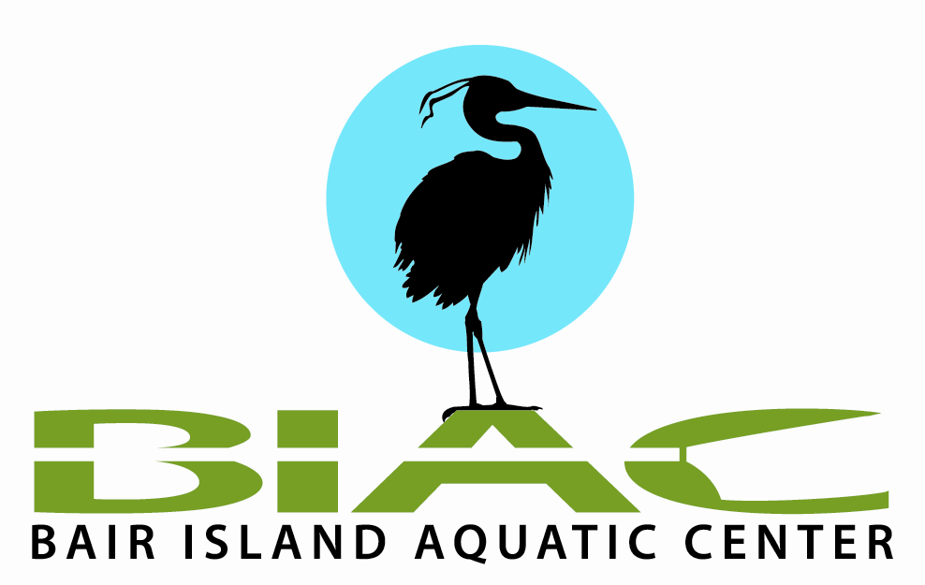
Please complete this form to report any serious incident - involving injury to persons or significant damage to equipment. Please report incidents within 24 hours of occurrence.
Send the original to the President or Secretary at Bair Island Aquatic Center.

Incident Date and Time: |  |  | Month: |  |  | Day: |  |  | Year: |  | Time: |  |  | am/pm
Your Name (incident contact person)
Address
Phone: | Work |  |  |  |  | Home
Where did the incident occur?
Injury or Damage? (please tick) |  |  |  |  |  |  | Injury |  |  | Damage
Types of boats (row, paddle, 8, 4-, 1x, etc):
Boats were … (please tick) |  |  |  |  | Racing |  | Training |  |  | Other:
Conditions: (please tick) Light: |  |  |  |  |  |  | Day time |  |  | Dusk |  |  | Night
Skies |  |  |  |  | Clear |  | Partly Cloudy |  |  | Overcast |  |  | Raining
Tide / Current |  |  |  |  | Low |  | Mid |  |  | High
Wind & Water: |  |  |  |  | Calm |  | Intermediate |  |  | Nasty!
Temperature: |  |  |  |  |  | Wind Direction (circle): N NE E SE S SW W NW
Name of club or event reporting incident
Your role at the club or event
What clubs or other parties were involved?
Description: Please detail the incident. If visibility was poor, what lights were being shown by all parties? Please include or attach any details (drawings / photographs) you feel will help.
Please continue on additional or separate sheets if necessary.
List any injuries; who treated them, and where.
Please list any damage to boat(s) or property.
Add or attach any further information you think may be useful, e.g. list of witnesses with addresses etc.
What has been, is recommended, or will be implemented to avoid repetition of similar incidents?
Signatures: |  | Date
Yours
Club Officer

